eDCU Life Time Tester
Operation Flashing User Manual
Document ID: 23-10-051-VTI-CCAIC-UM
Rev.: 2.0
Safran Data Systems Pvt Ltd
 | Name | Signature | Date
Prepared By | Ananth A
Reviewed By | Prabhakar T J
Approval By | Midhunseelan O S

Customer
 | Name | Signature | Date
Reviewed By
Approved By

Document ID | 23-10-051-VTI-CCAIC-UM
Document Name: | Operation Flashing User Manual
Document No.: | R/PP-03/25
Project/Product Name: | eDCU Life Time Tester
Project/Product Code: | 23-10-051-VTI-CCAIC
Revision Status: | 2.0

Change Summary

Release No. | Date | Changed By | Change Description
Version 1.0 | 09-01-2024 | Ananth A | Initial Version

Desktop Panel
By clicking the “Application” button in the main screen. below shown User window will appear.
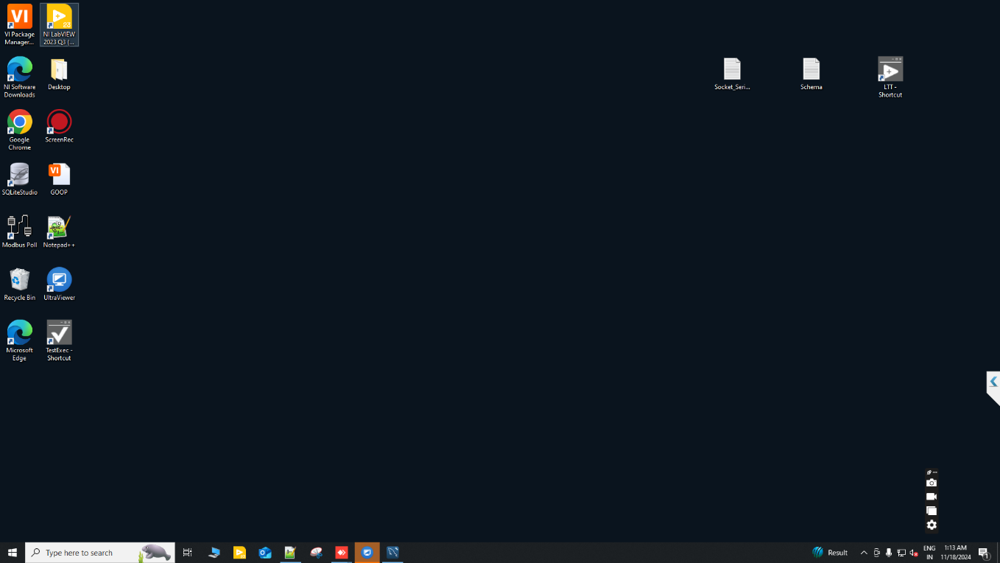
Click on “Application” button.
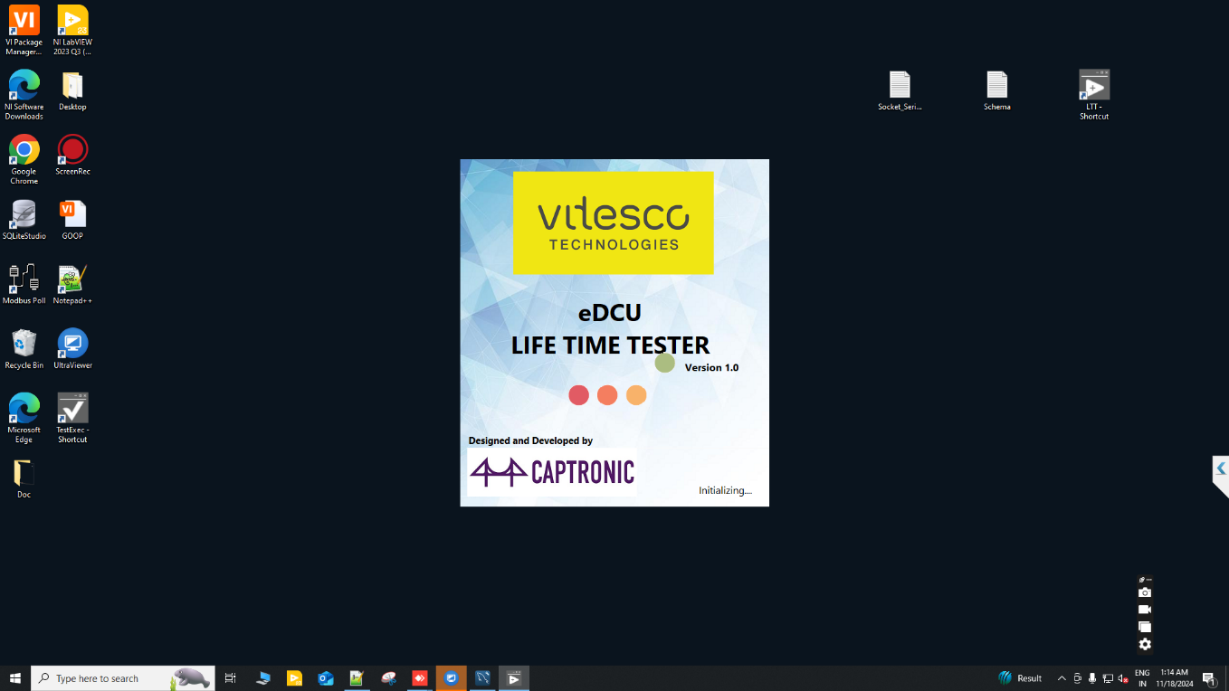

Main Login:
Enter the “User Name” and “Password” Button from the Login screen below the user screen will appear. Click “Sign In”.

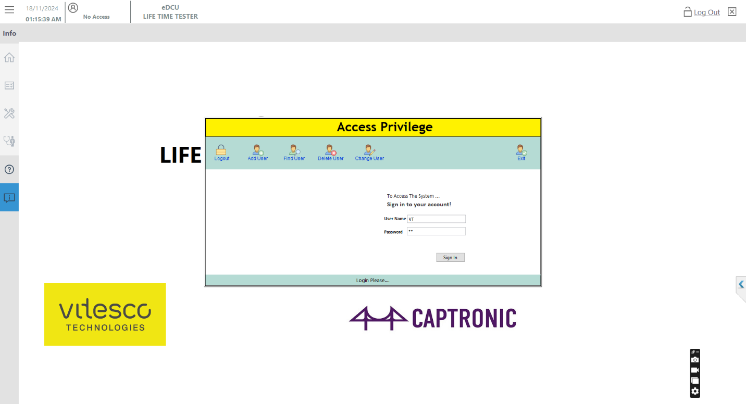
Enter the UserName and Password then Click “Sing In” button.

Clicking the “Login OK” Button from the main screen below the user screen will appear. Click “OK”. 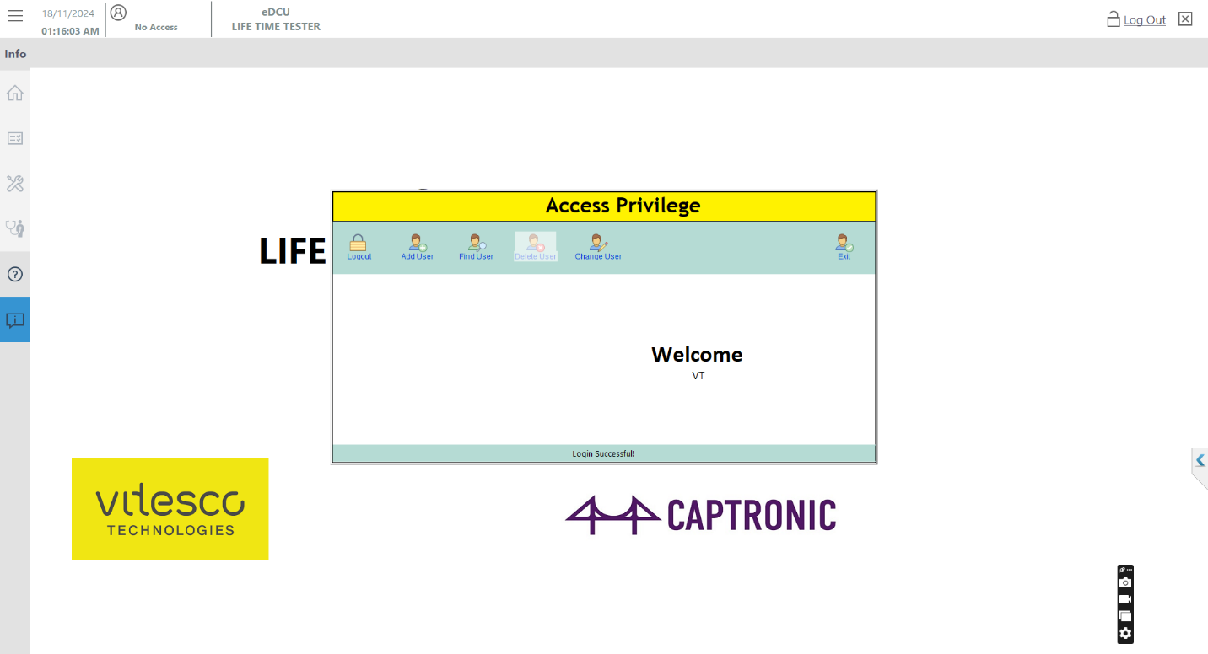
Enter the Login Successful Click “Exit” button.

Auto Mode:
Clicking the “Login Successful” Button from the Click ”Diagnosis mode” screen below the user screen will appear. “Auto Mode GUI”.
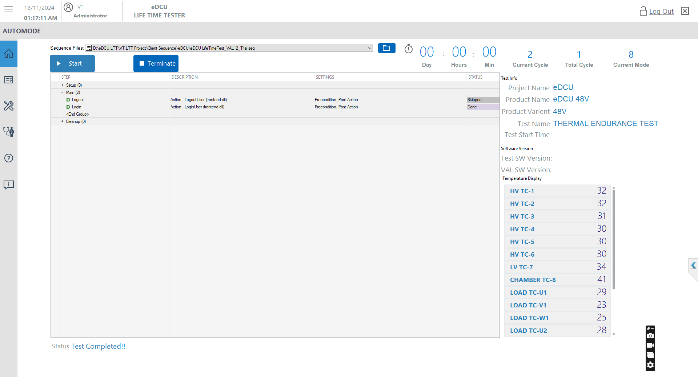
Enter the Login Successful Click “Exit” button.

Test stand Login:
The “Auto Mode Successful” Button from the Click ”TestStand Login” screen below the user screen will appear. “Login”.

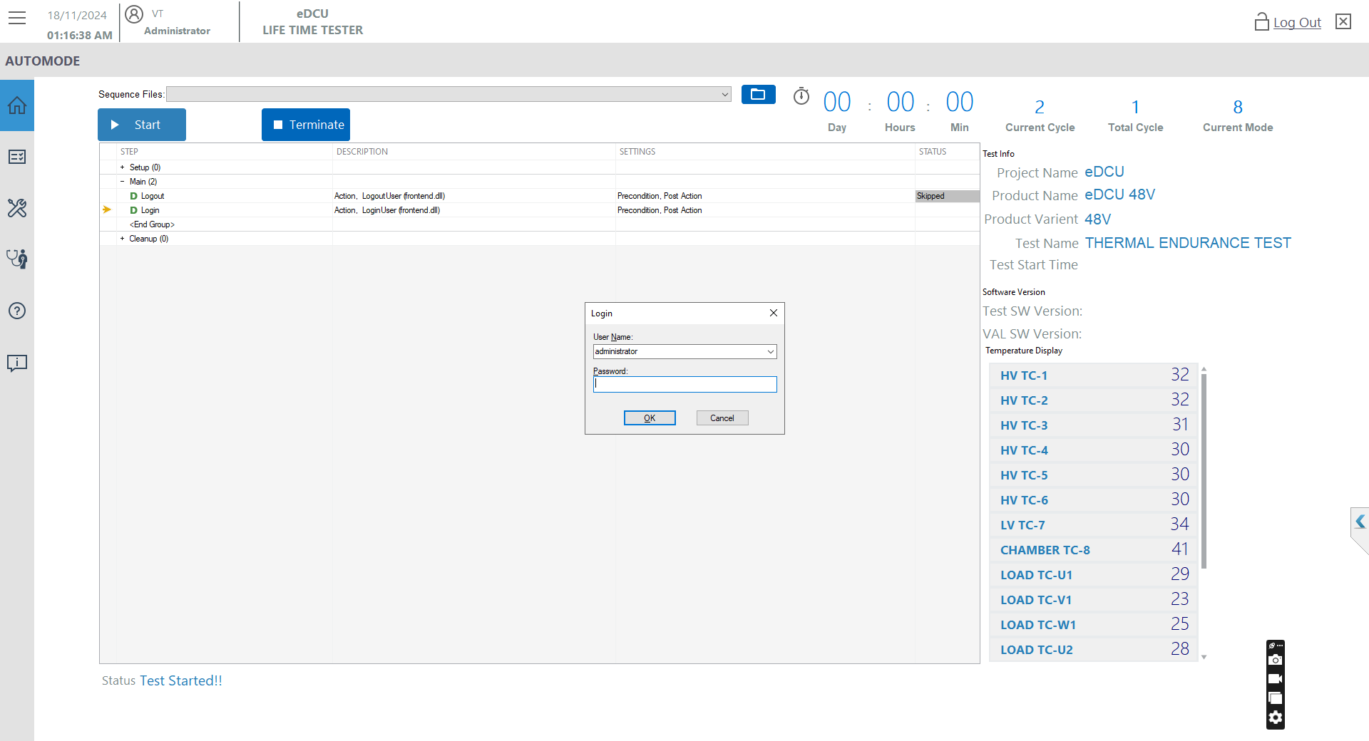
Click “OK” button.

Sequence Selection:
Press the Open Sequence Files then Select the “eDCU Software Flashing Sequence.seq” Sequence from the path. screen below the user screen will appear. Click “OPEN”
Path: D:\eDCU LTT\VT LTT Project\Client Sequence\eDCU\Software Flash

Open “Sequence File”.

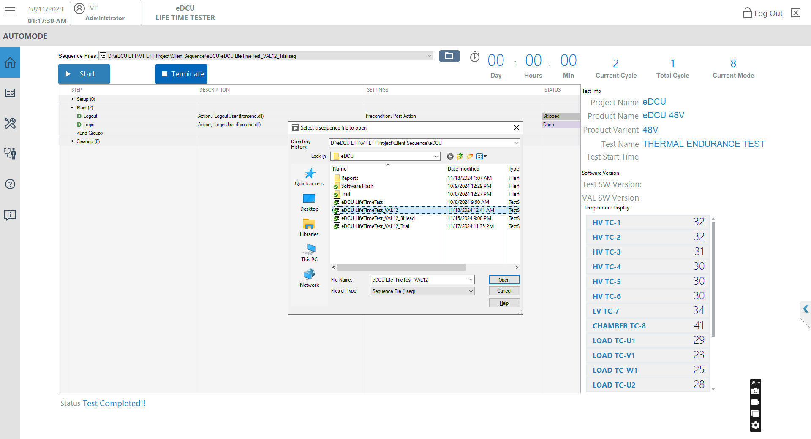
Select “eDCU Software Flashing Sequence”.
Final Click “OPEN”.

Test Windows:
Press the “Start” Flashing Sequence from the path. screen below the user screen will appear.
Path: D:\eDCU LTT\VT LTT Project\Client Sequence\eDCU\Software Flash\ eDCU Software Flashing Sequence.seq

Click Test Start Button “Start”.

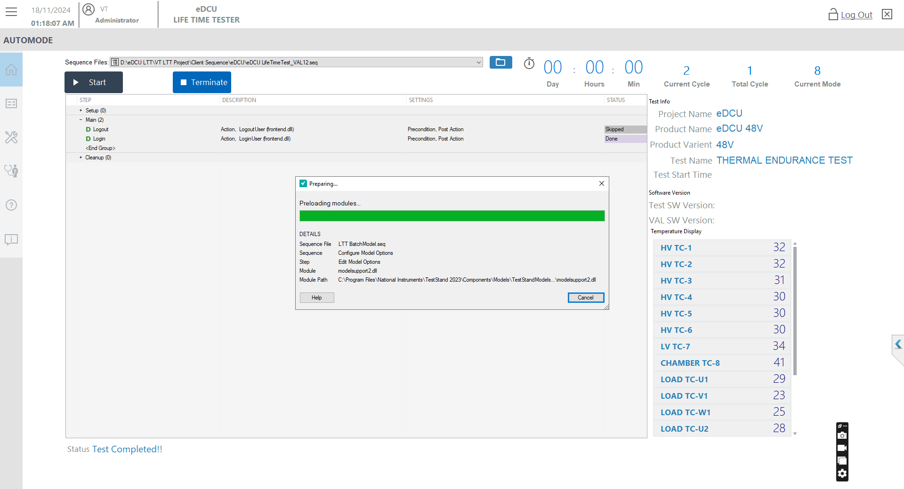

Socket Entry Windows:
Press the “OK” IF “6”. The screen below the user screen will appear.

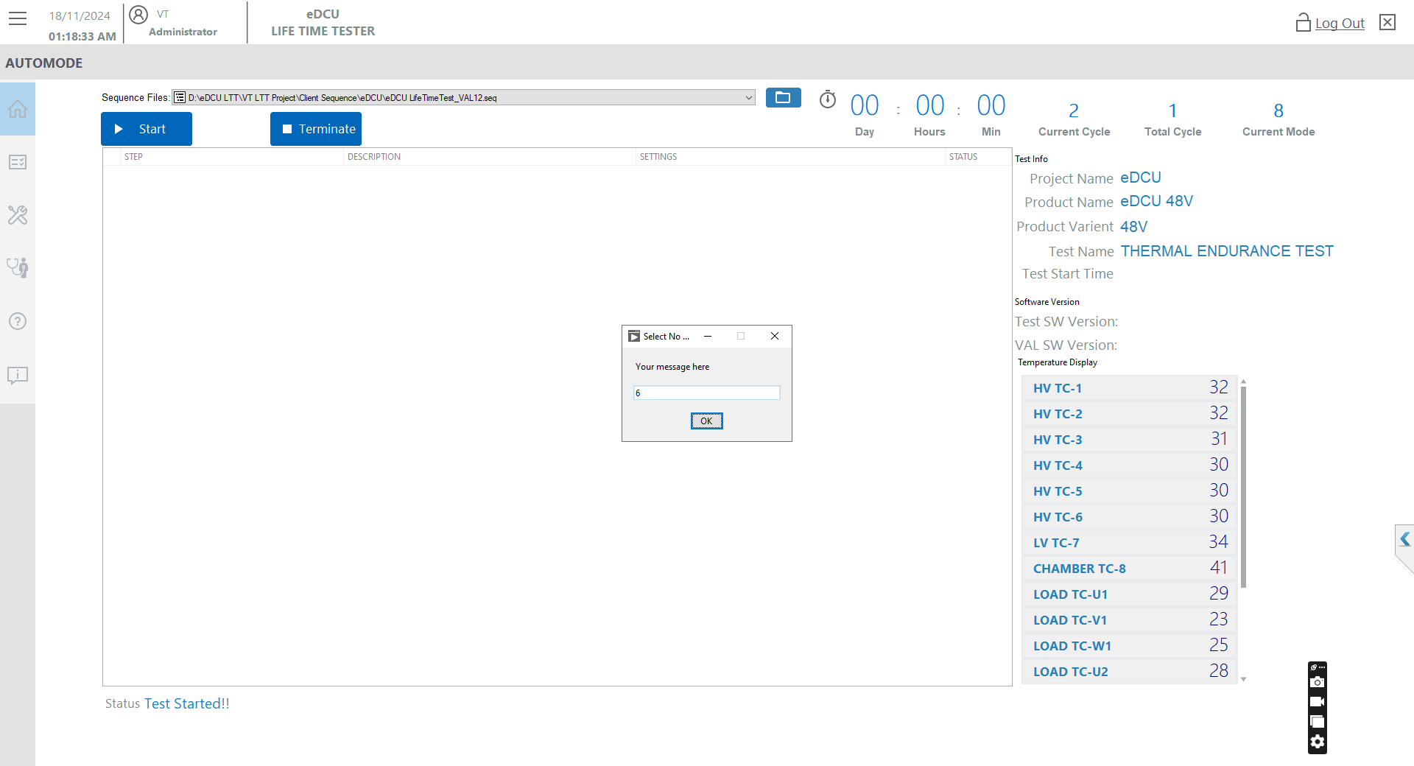
Click “OK”.

UUT Info Entry Windows:
Enter the “Batch Number ” and “All Serial Number Enter”. The screen below the user screen will appear.
Batch No “Any Number”.
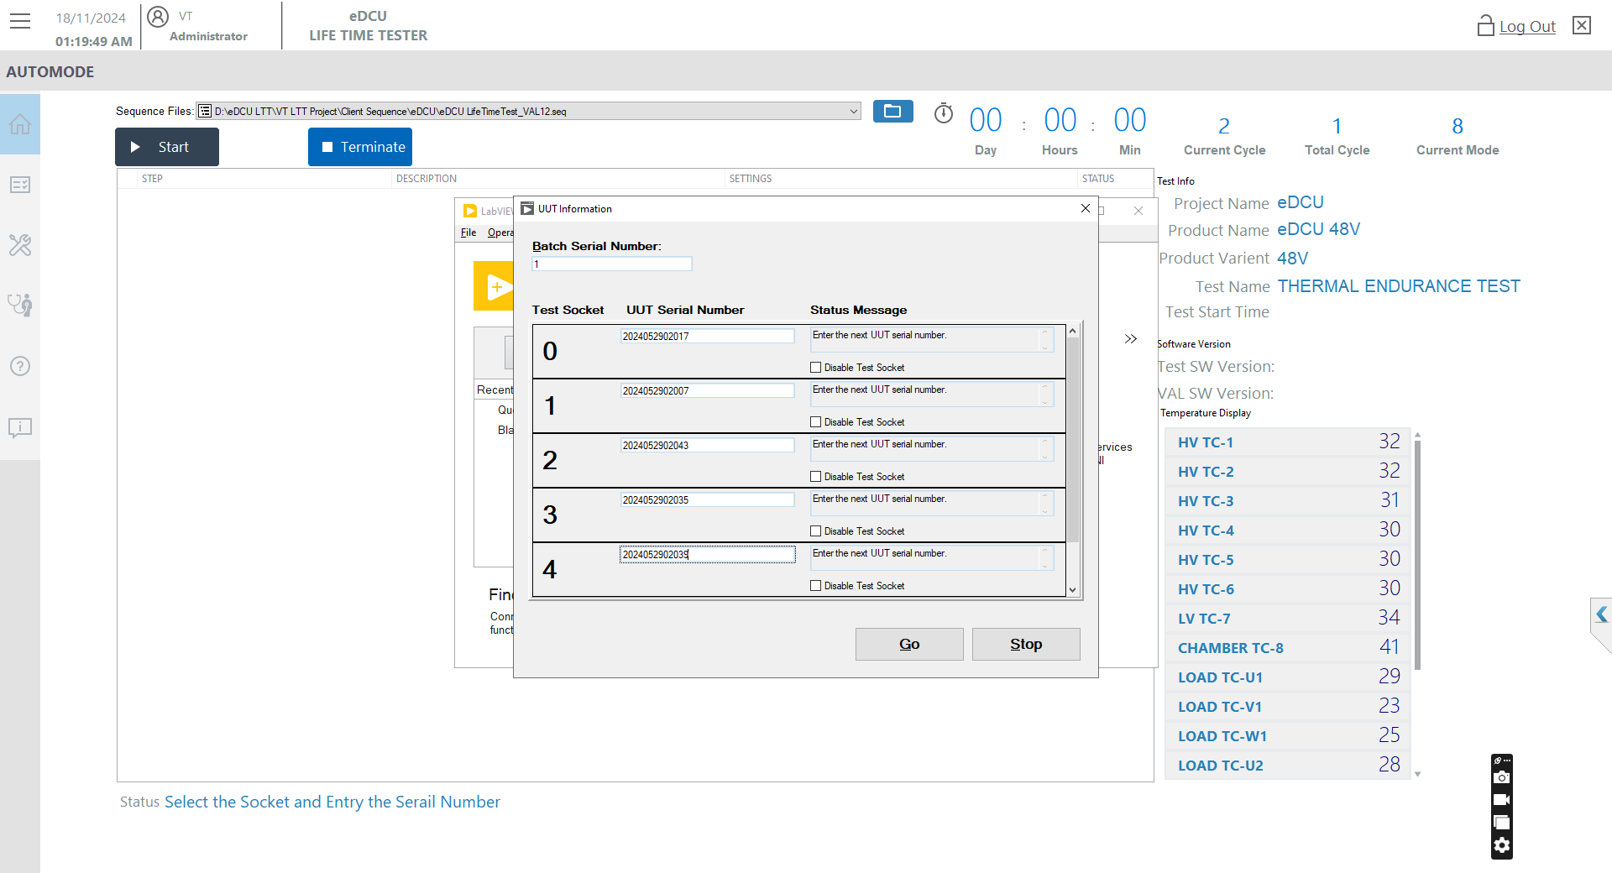
Enter all Serial No “Any Number”.

UUT Info Entry Scroll Windows:
Enter the “Batch Number” and “All Serial Number Enter” and Proceed to “GO” The screen below the user screen will appear.


After all Entry only Click “GO”.

Test Selection Windows:
Click the “New Test”. The screen below the user screen will appear.

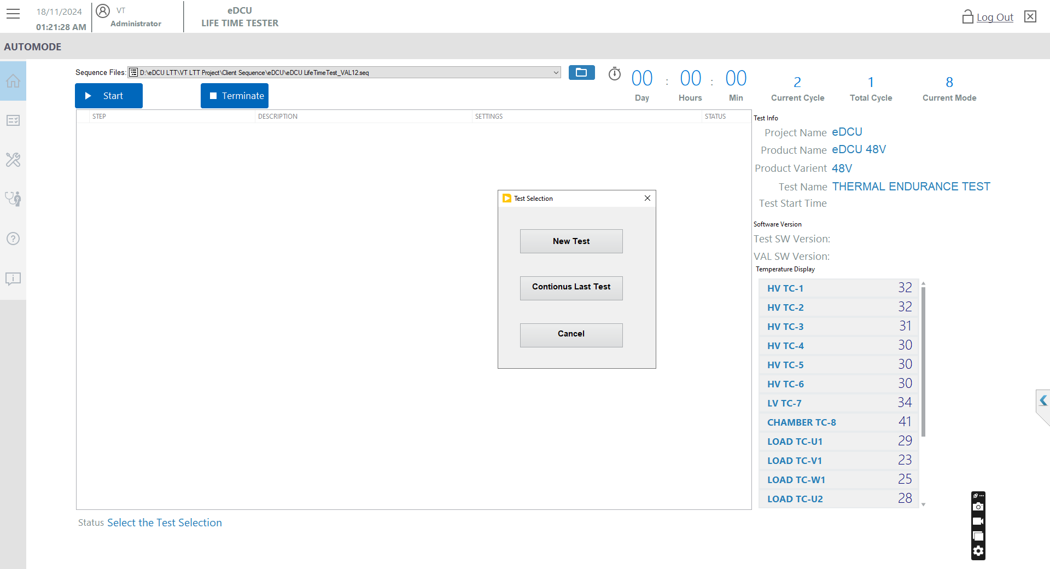
Click “New Test”.

Schema Selection Windows:
Select the schema “File mention the name Schema Select Dropdown bar”. The screen below the user screen will appear.

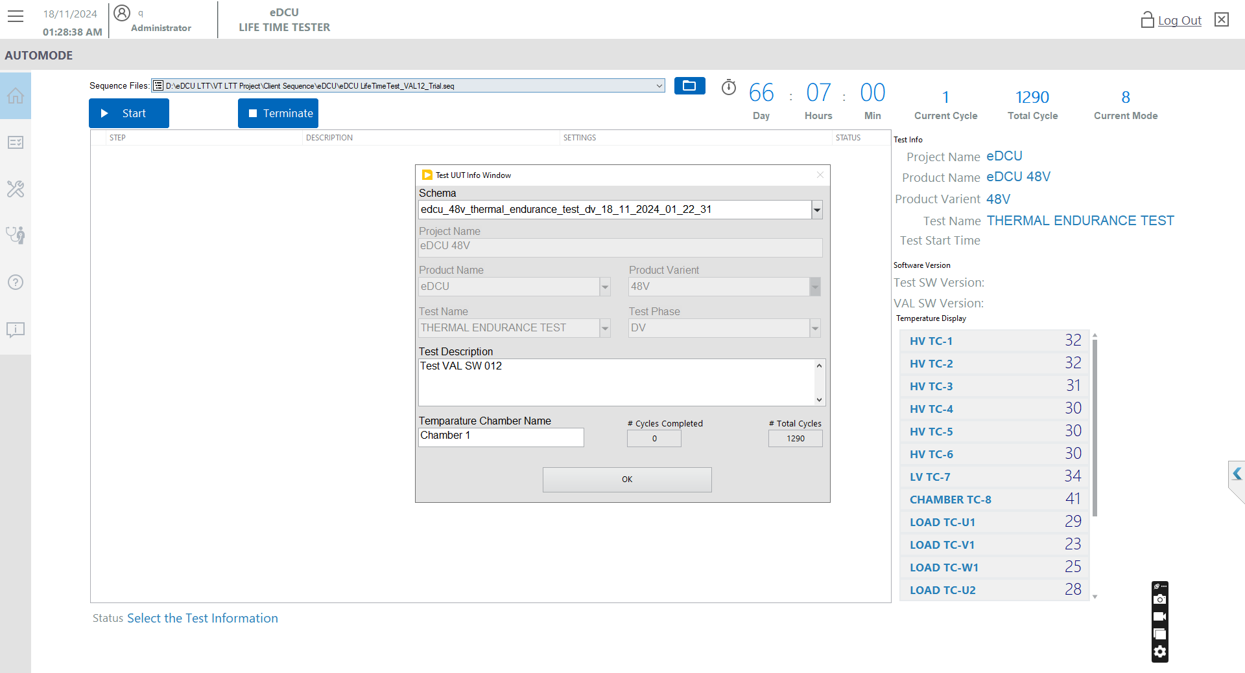
Test Info Entry
“OK”.
Enter the description
“Details Entry”.

Flash Sequence selection Windows of Monitor:
Select open the sequence File Path and the Software Flashing Sequence display the windows then Start the Test. “Running Display” screen below the user screen will appear.
Open the File Path
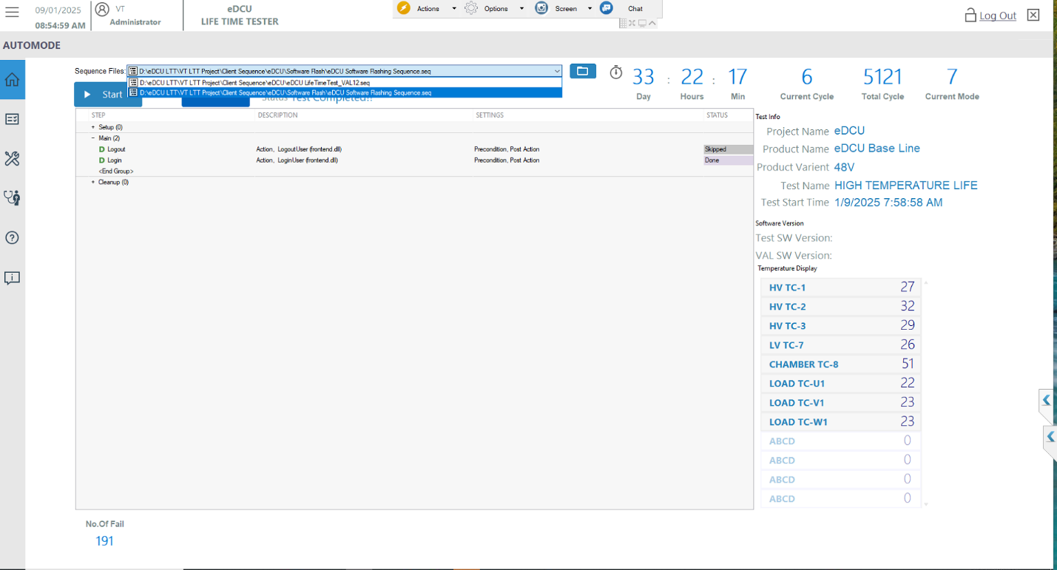
Start the Test
Select the Software Flashing Sequence

Existing software read Procedure:
Existing Software read TSW and VAL SW Version showing Popup and Click the button “OK”. screen below the user screen will appear.
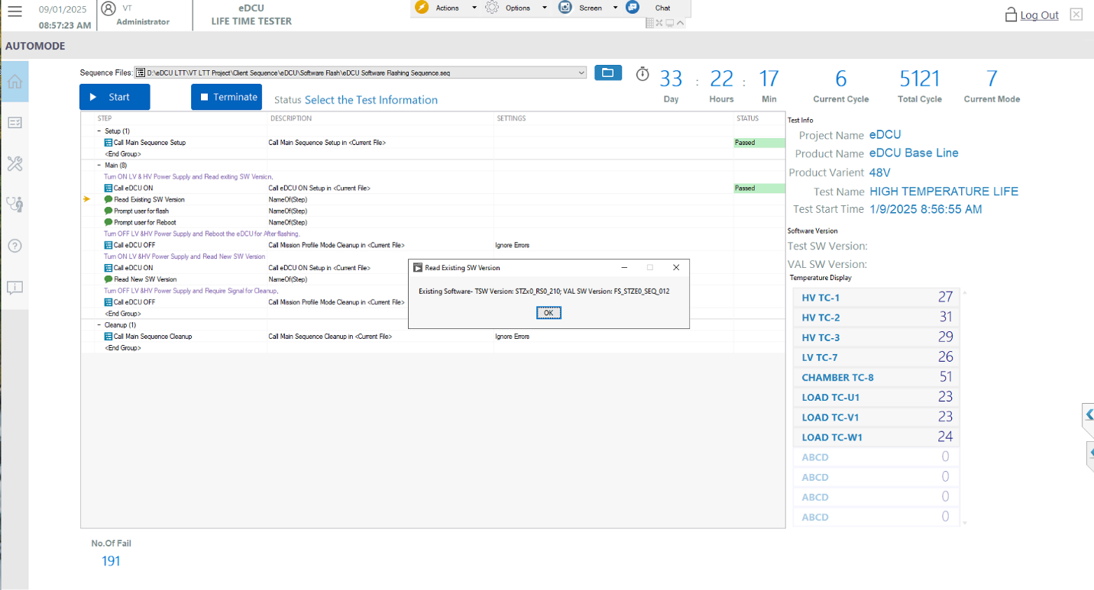
Existing Software Version Read and the Click the “OK”

Proceed the flash Test Procedure:
Proceed the flash the eDCU and After flashing click the “OK” showing Popup. screen below the user screen will appear.

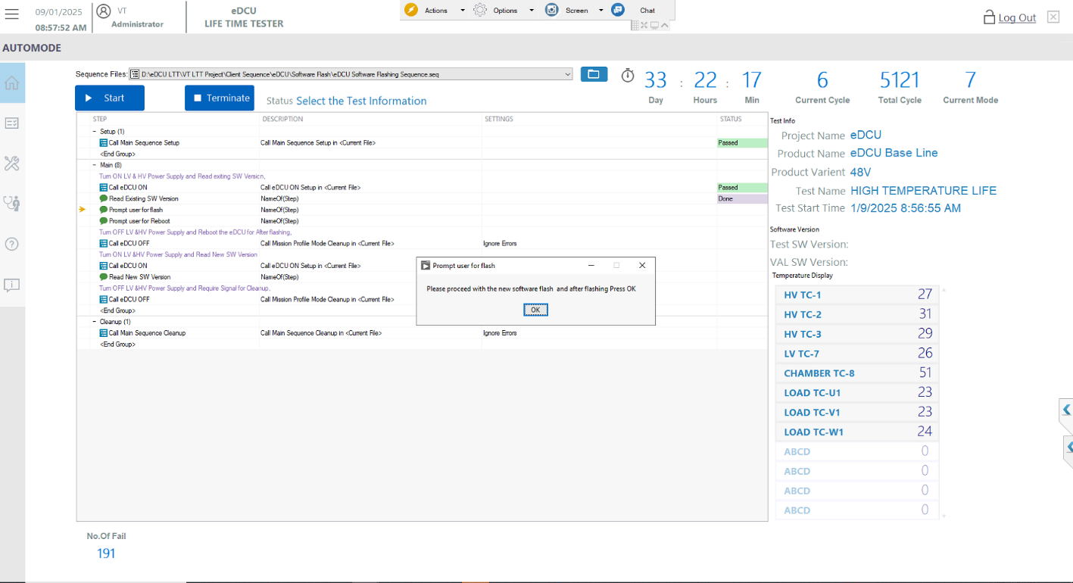
Proceed the Flash eDCU and the after flashing Click the “OK”

Reboot Test Procedure:
Proceed the reboot the eDCU click the “OK” showing Popup. screen below the user screen will appear.
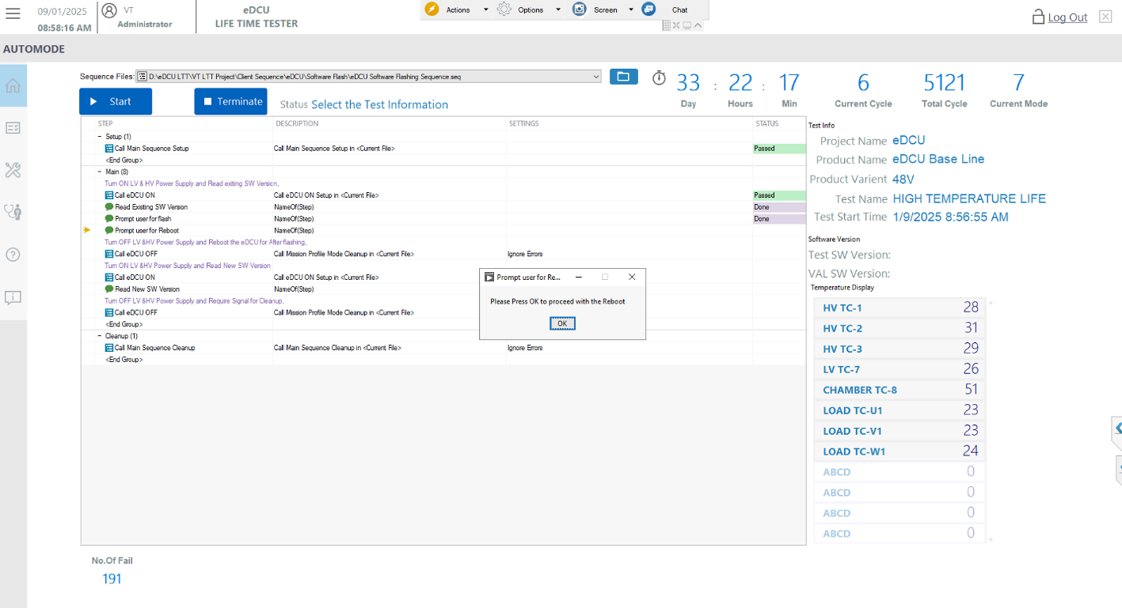
Proceed the reboot eDCU Click the “OK”

New Software Read Procedure:
New Software read TSW and VAL SW Version showing Popup and Click the button “OK”. screen below the user screen will appear.
.

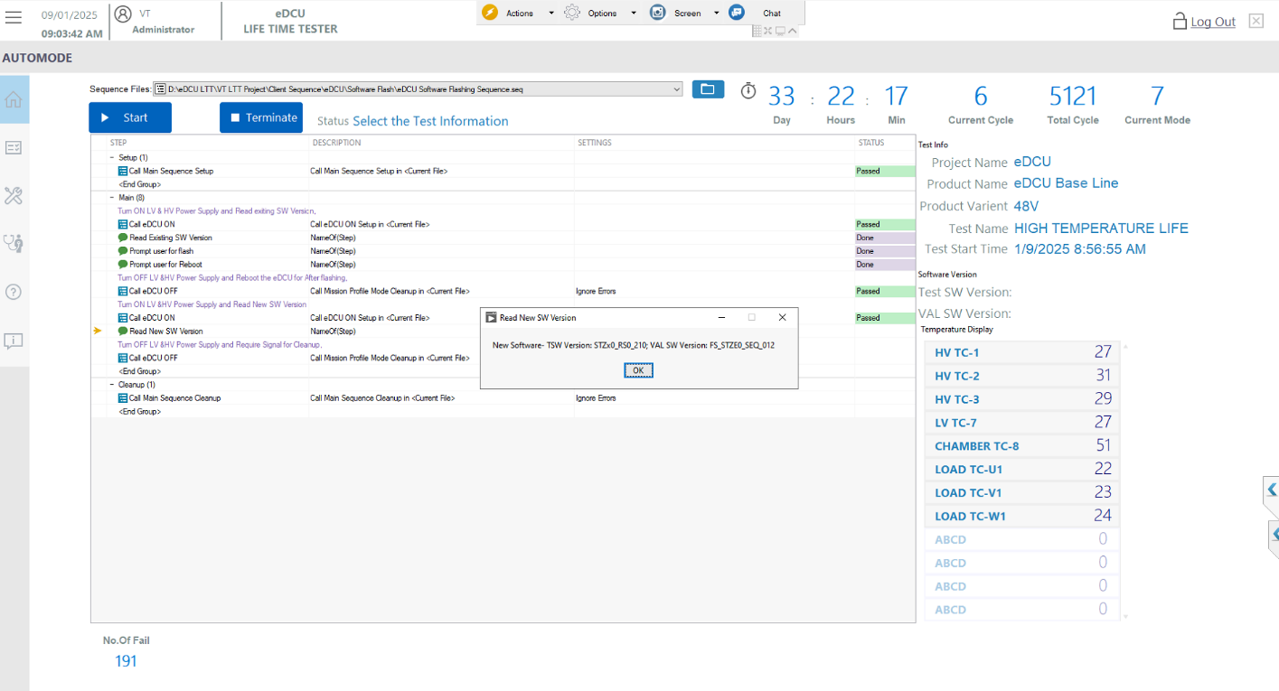
New Software Version Read and the Click the “OK”

Diagnosis Test Procedure:
Click the Diagnosis button will appear screen and use flashing need use the access the driver Programmable power supply and Digital Output. screen below the user screen will appear.

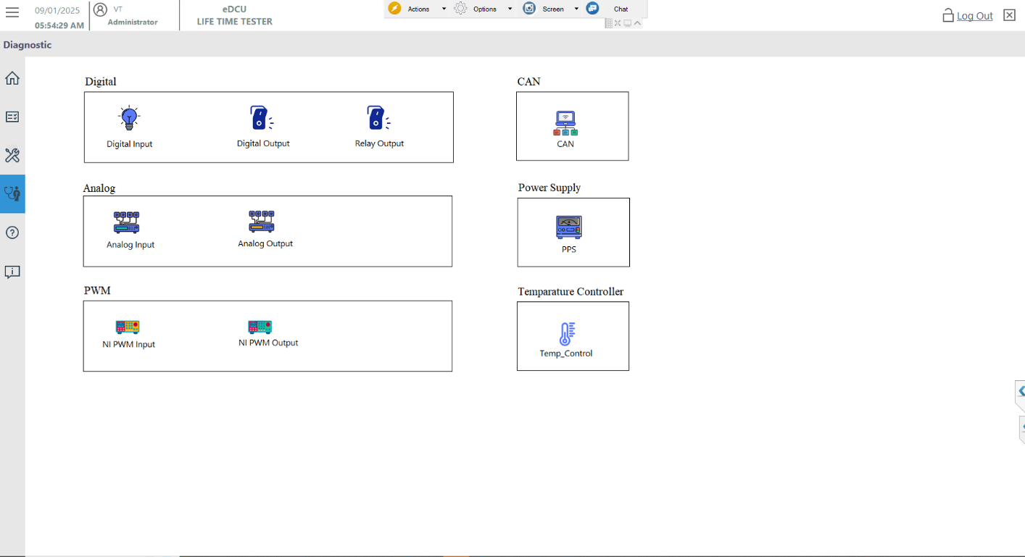
Click the Relay Output for Low Voltage PPS used eDCU “12V”
Click the PPS for High Voltage PPS and Low Voltage PPS Click the “OK”
Click the “Diagnosis Button”

Power Supply Selection Test Procedure:
Click the PPS button and Selection list mention LVPPS, HVPPS (Based the socket selection HVPPS) the Run Cleanup and tick the Don’t show again batch execution then click the OK. screen below the user screen will appear.

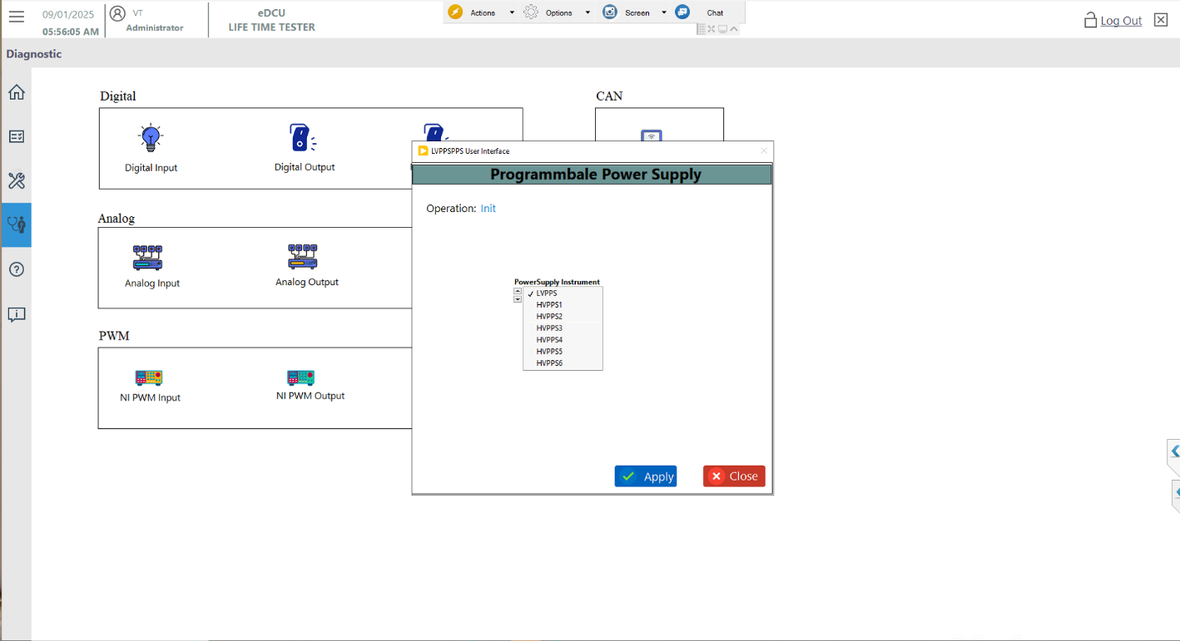
In the Operation “Init” and Select the PPS Selection “LVPPS or HVPPS(Based Socket)

High Voltage PPS Initialize Test Procedure:
HVPPS initialize the instrument then click the Apply. screen below the user screen will appear.
- Select the PPS Selection LVPPS or HVPPS(Based Socket 0 Ex:- HVPPS1).
- Final Click the Apply Button.
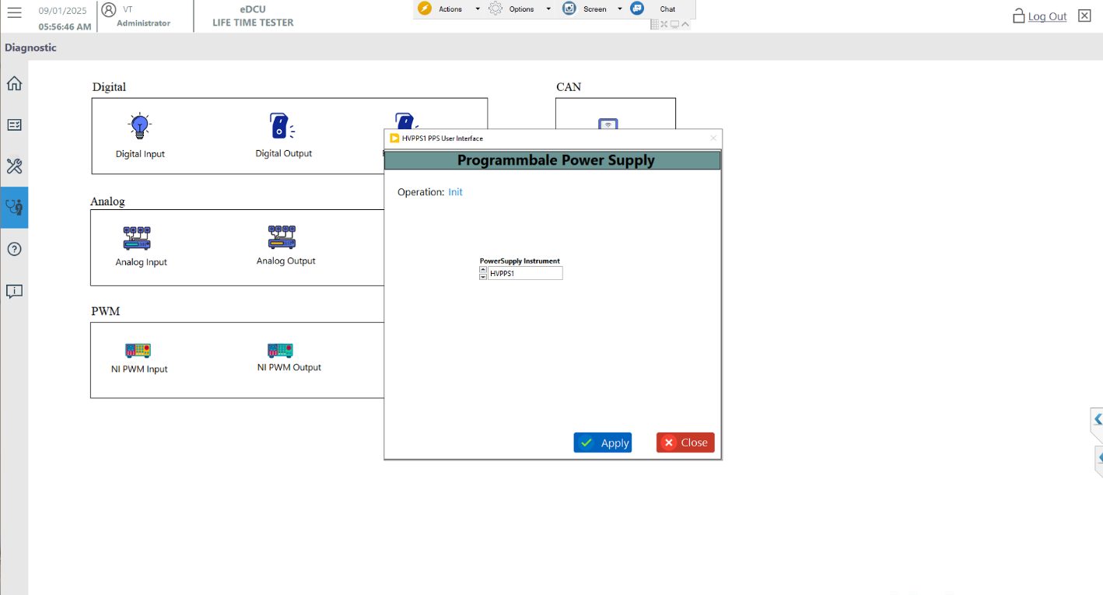
In the Operation “Init” and Select the PPS Selection “LVPPS or HVPPS(Based Socket)

Final Click the “Apply”

High Voltage PPS Configure Test Procedure:
HVPPS Pre configuration and Enable the Output Only click the OK. screen below the user screen will appear.
- Configure the Enable Output Button.
- Final Click the Apply Button.

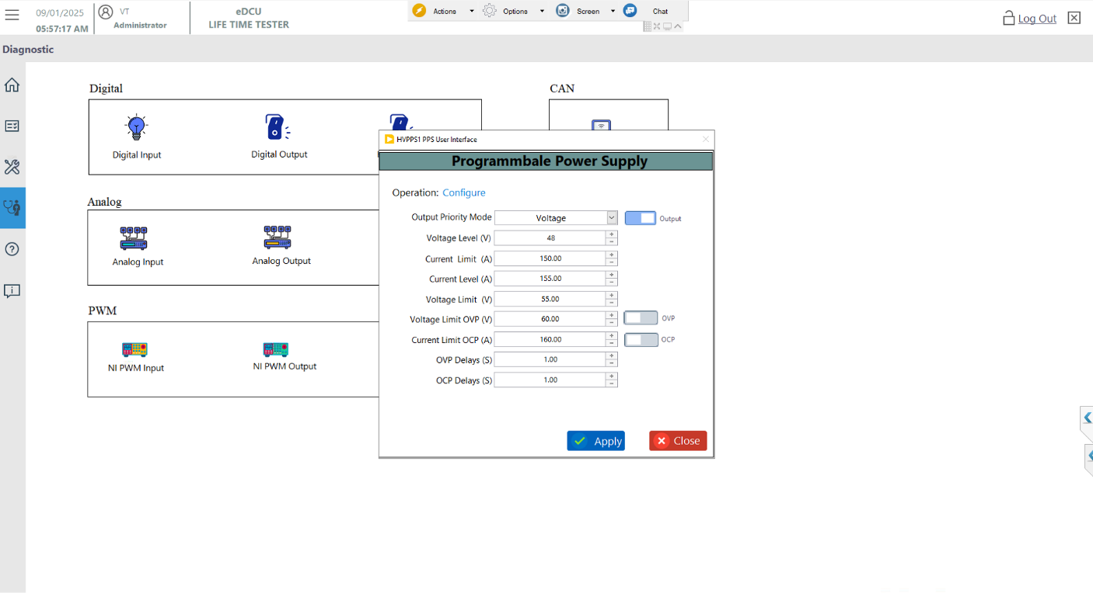
Selected PPS Name Mention for “ Title Bar”
In the Operation “Configure” and Enable the Output
Final Click the “Apply”

High Voltage PPS Digital Output Test Procedure:
eDCU 48V Positive and Negative Digital Output Enabled and Write. screen below the user screen will appear.
- Enable the 48V Positive and Negative Output.
- Click the Start Button.
- Finally Click the Write Button.
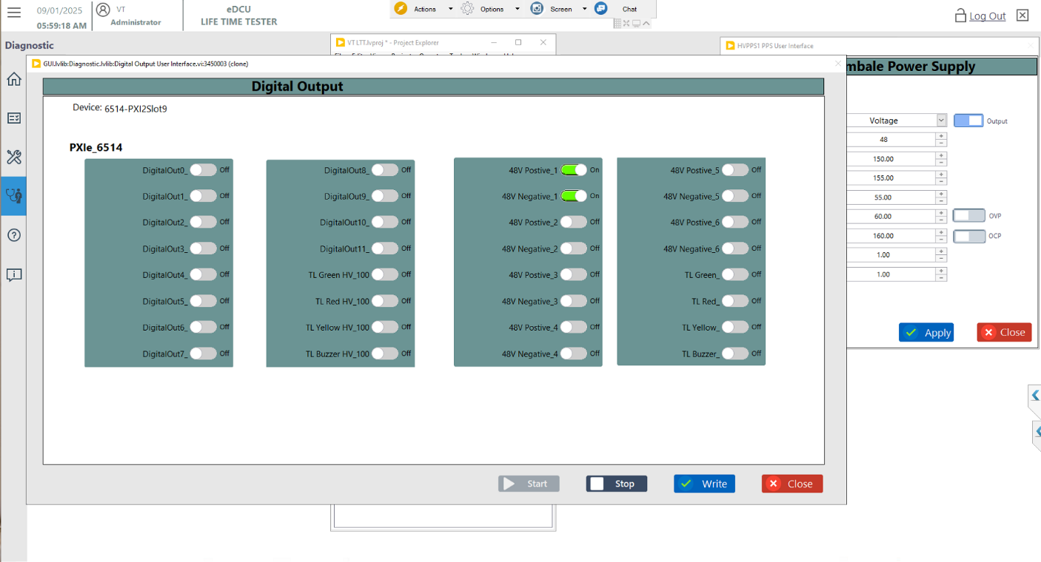
2.Click the Button “Start”
1.Enable the “48V Positive and Negative Output” All”

1.Final Click the “Write”

Low Voltage PPS Initialize Test Procedure:
HVPPS initialize the instrument then click the Apply. screen below the user screen will appear.
- Select the PPS Selection LVPPS or HVPPS (Based Socket 0 Ex:- HVPPS1).
- Final Click the Apply Button.
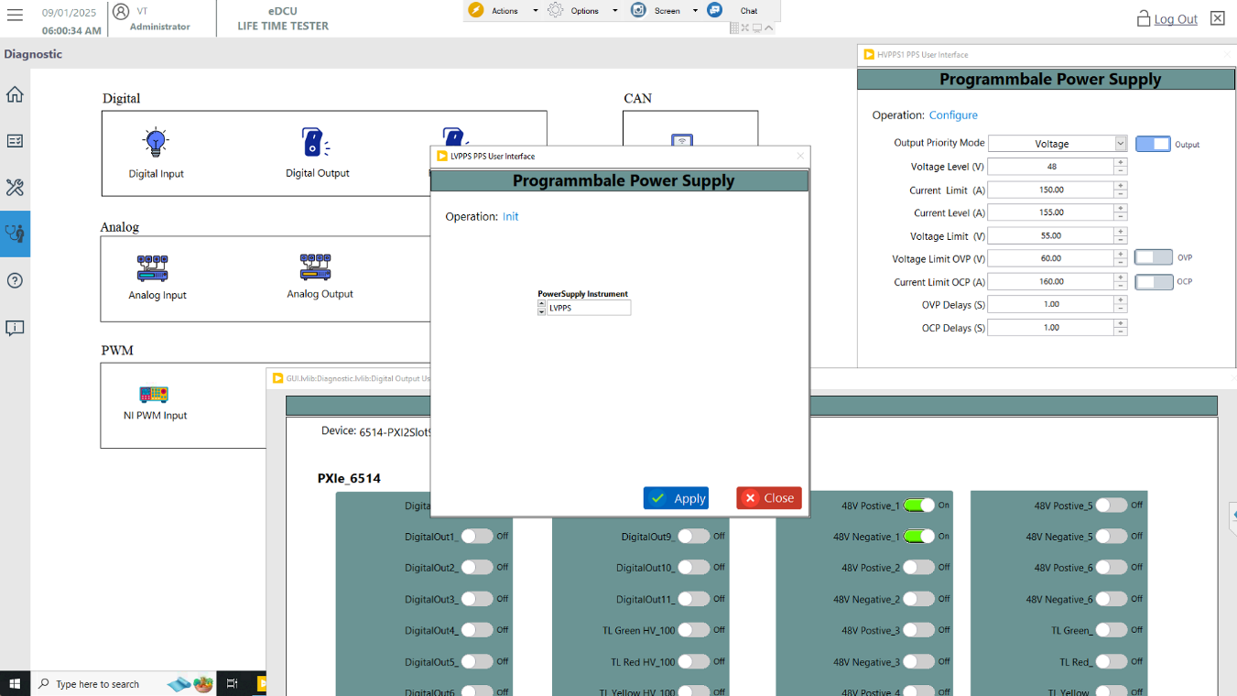
In the Operation “Init” and Select the PPS Selection “LVPPS or HVPPS(Based Socket)

Final Click the “Apply”

Low Voltage PPS Configure Test Procedure:
HVPPS Pre configuration and Enable the Output Only click the OK. screen below the user screen will appear.
- Configure the Enable Output Button.
- Final Click the Apply Button.

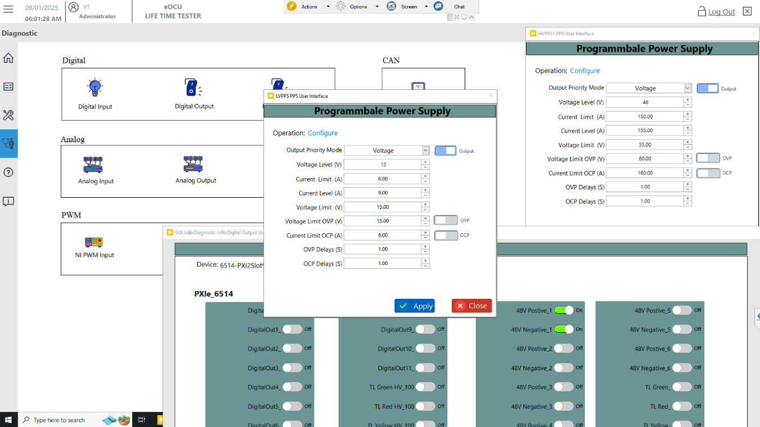
Selected PPS Name Mention for “ Title Bar”
In the Operation “Configure” and Enable the Output
Final Click the “Apply”

Figure 15: Test Info Schema Selection

Low Voltage PPS Relay Output Test Procedure:
eDCU 12V Positive and Negative Relay Output Enabled and Write. screen below the user screen will appear.
- Enable the 12V T30 and T30 GND Output.
- Click the Start Button.
- Finally Click the Write Button.

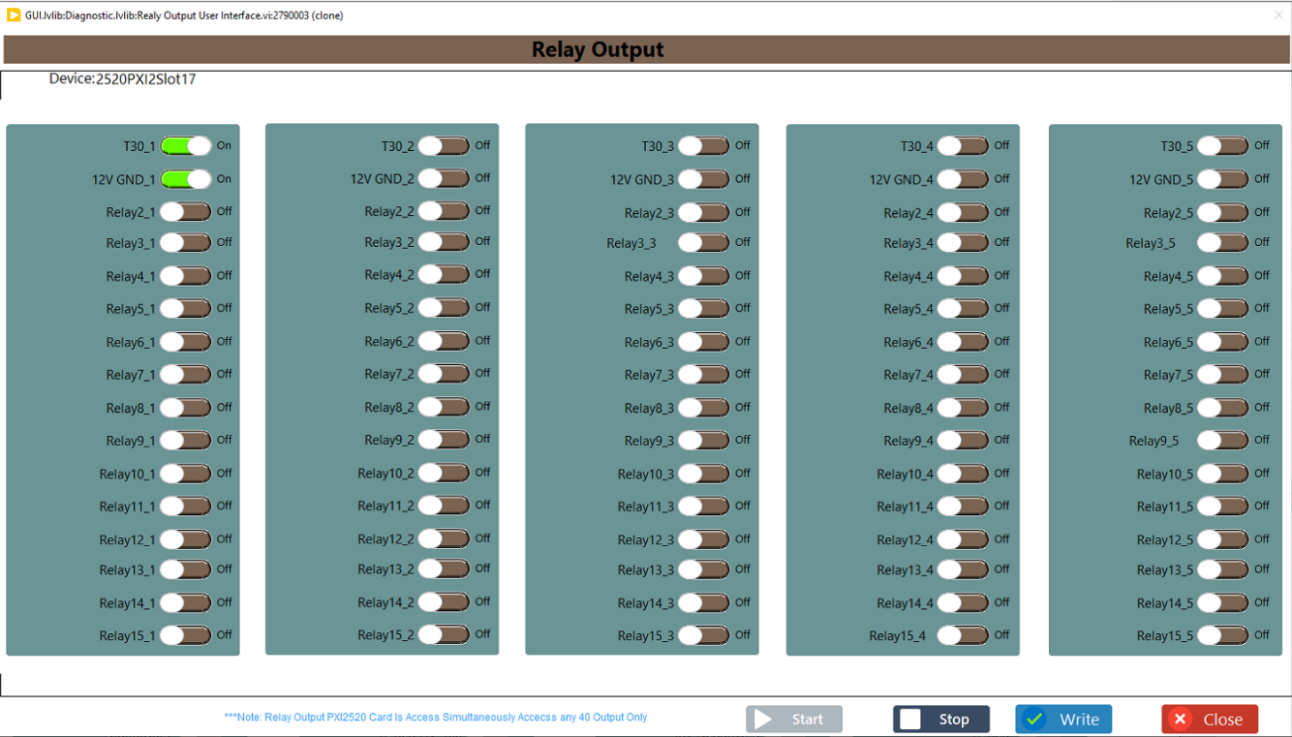
1.Enable the “T30 and T30 GND Output” All”

1.Final Click the “Write”

2.Click the Button “Start”

CAN Configure Port Test Procedure:
CAN configure the port based on socket. screen below the user screen will appear.

- Click the Tab Configure
- Based Socket CAN port selection( Ex: Socket0-CAN2, Socket1-CAN4)
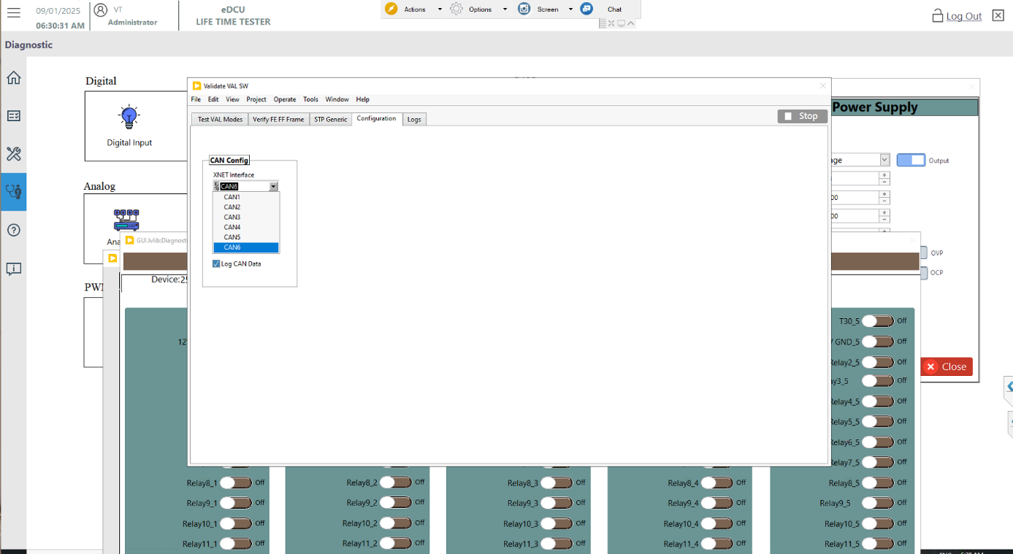
Based Socket CAN port selection
Click the Tab “Configure”

CAN Read Test Procedure:
Click the CAN Read the VAL SW the read. screen below the user screen will appear.

- Click the Tab Test VAL Modes Button
- Click the Button TSW version read
- Click the Button VAL version read

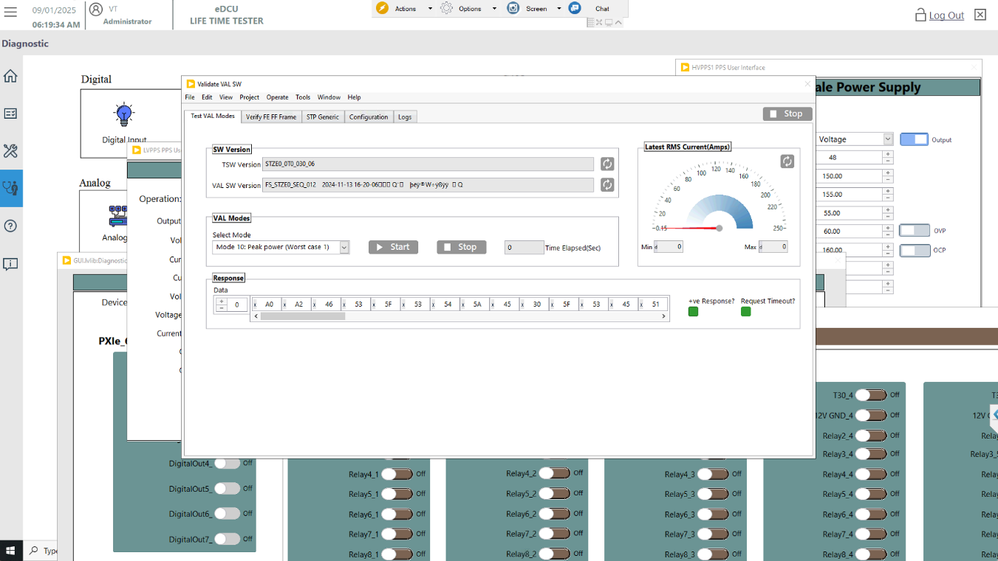
Click the Button “VAL version”

Click the Button “TSW version”
Click the Tab “Test VAL Modes”

